1. Display the minimum Status in the Supplier table.

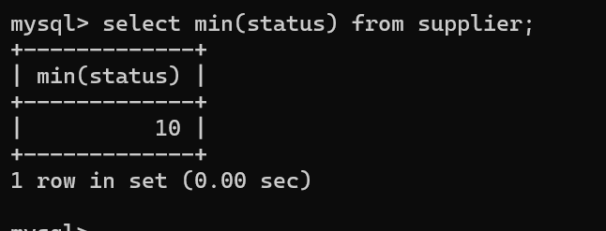

2. Display the maximum Weight in the Parts table.

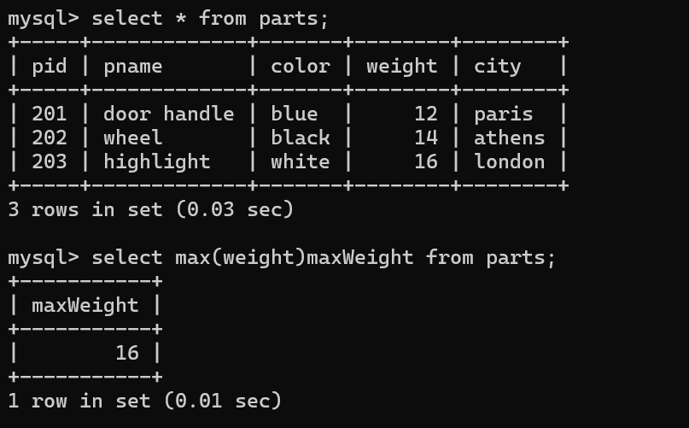

3. Display the average Weight of the Parts.

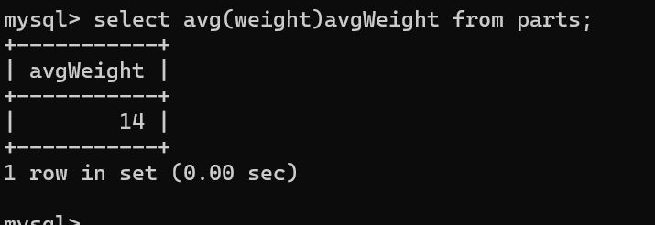

4. Display the total Quantity sold for part ‘P1’.

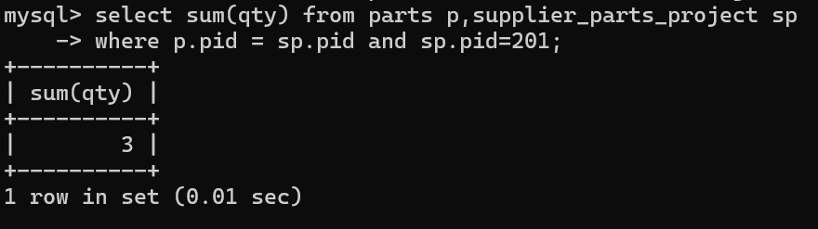

5. Display the total Quantity sold for each part.

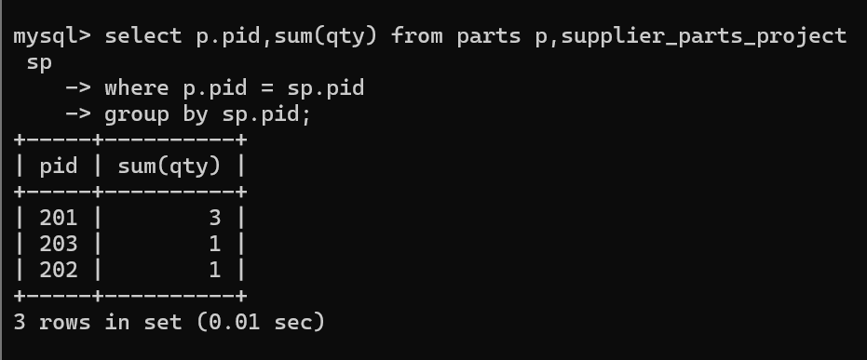

6. Display the average Quantity sold for each part.

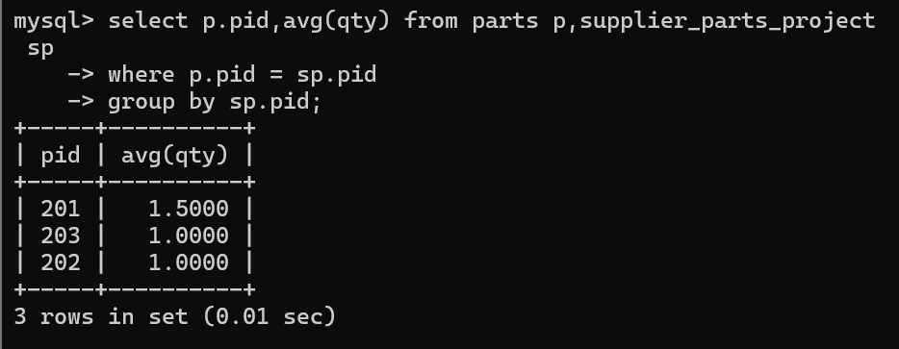

7. Display the maximum Quantity sold for each part, provided the maximum Quantity is

greater than 800.

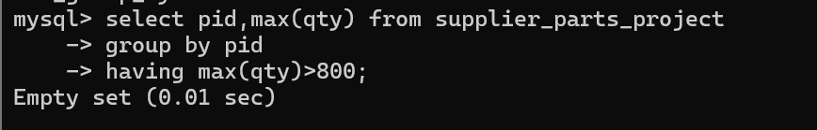

8. Display the Status and the count of Suppliers with that Status.

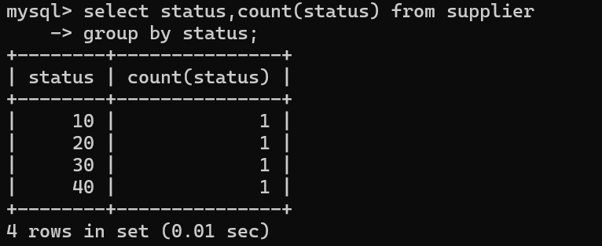

9. Display the count of Projects going on in different cities.

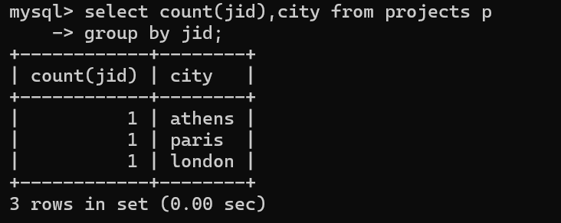

10. What is the difference between COUNT(Status) and COUNT(*) ?

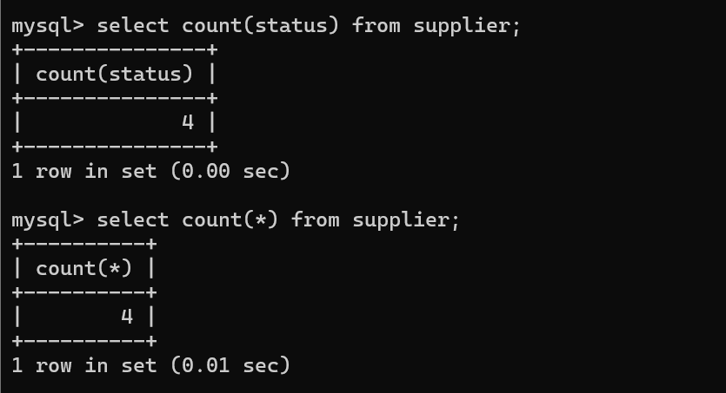

**We can able to see in below query that in ‘parts table’ ,‘status’ column is not present**

**There count(status) is giving error**

**But count(*) is printing total number of row in that table**

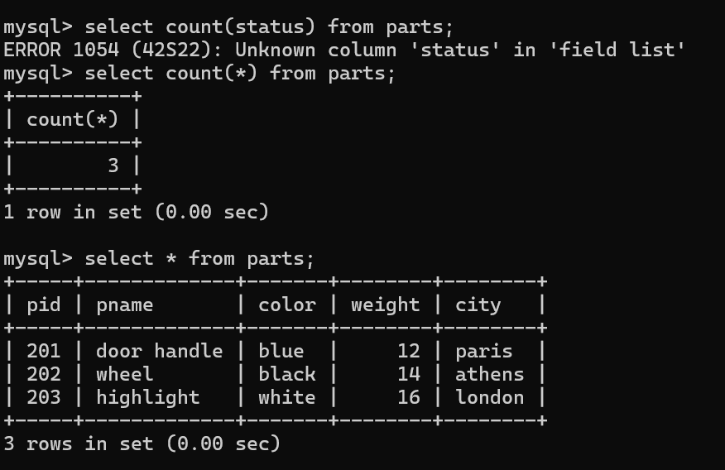

11. Display the Status and the Count of Suppliers with that Status in the following format

as shown below:-

Status Count

Ten 1

Twenty 2

Thirty 3

